# Class Exercise #2 – HTML Elements

Instruction (completing this instruction – 10/50 points):

1. Similar instruction to Class Exercise #1’s instructions, addition step is #5 of this instruction.

2. Please use MS Windows 10 Snipping Tool to take screen shot of the following Tasks, **make sure it is legible and readable screen shot. If you can’t read it, I can’t read it.**

2. Please put your full name in the header.

3. Please do not modify this document to another format, keep as MS Word with .docx.

4. Submit this document to eCampus > Submit Your Assignment Here > Class Exercise #2 Submit Here. Refer to the syllabi for due date.

5. Upload your index.html page to the web server, using FileZilla FTP account information, to your web directory.

You will need to follow the sequential steps from Task A, B, C, etc…. to complete this assignment.

**Part 1 – Task A, B and C – Create table for index.html, tables, links from index to helloworld html files**

**Part 2 – Task A, B and C -**

==========================================================================================

**Part 1 – Task A, B, and C – Starts here**

==========================================================================================

## Part 1 - Task A: Creating table for index page.

Introduction

You may want to consider using HTML tables in your website. In addition to creating HTML tables to present data in rows and columns, you can also create HTML tables to organize information on your web page.

The process of creating an HTML table is similar to the process that you used to create your web page and any elements that you may have already included in your page, such as links or frames. Coding HTML tables into your web page is easy since you need only understand a few basic table codes.

The basic structure of an HTML table consists of the following tags:

* Table tags:  <TABLE> </TABLE>
* Row tags:   <TR> </TR>
* Cell tags:    <TD> </TD>

Constructing an HTML table consists of describing the table between the beginning table tag, <TABLE>, and the ending table table tag, </TABLE>. Between these tags, you then construct each row and each cell in the row. To do this, you would first start the row with the beginning row tag, <TR>, and then build the row by creating each cell with the beginning cell tag, <TD>, adding the data for that cell, and then closing the cell with the ending cell tag, </TD>. When you finish all of the cells for a row, you would then close

the row with the ending row tag, </TR>.Then, for each new row, you would repeat the process of beginning the row, building each cell in the row, and closing the row.

The following table is an example of a basic table with three rows and two columns of data.

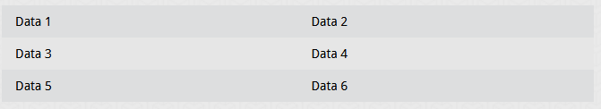

The codes that generated this table look like this:

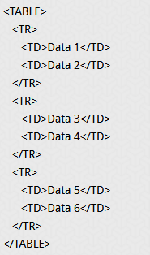

This table contains no border, title, or headings.  If you wish to add any of these elements to your table, you need to include additional HTML codes.  The codes for these elements are explained in the next section.

1. Watch these videos, copy and paste these links to your web browser:

Part 1 – Task A.1 - <https://www.youtube.com/watch?v=y5yImZfMHcM>  
  
Part 1 – Task A.2 - <https://www.youtube.com/watch?v=r21KjSGAkvc>  
  
Part 1 – Task A.3 - <https://www.youtube.com/watch?v=iUpl9gPdOso>  
  
Part 1 – Task A.4 - <https://www.youtube.com/watch?v=aYgitgfCZng>

For your **index.html** page, please use MS Visual Code and create the following table with three columns, ten rows, looks like this below:

The following table images does not have a border, width, cellpadding and align attributes.

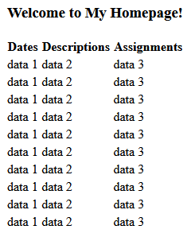

2. Use the Windows > Snipping Tool and take screen shot of the table, copy and paste below:

## Part 1 - Task B - Adding a border, title, and headings

In addition to the basic table tags, several options are available for adding additional elements to your table. For example, if you add a border, title, and column headings to the table in the previous section, the table would then resemble the following:

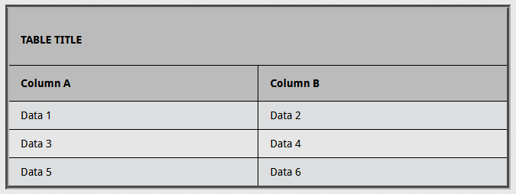

The following codes generated the border, TABLE TITLE, and Column A and Column B headings for this table:

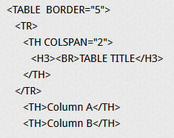

Note:  If you wish to view the codes that generated the Data 1 through Data 6 cells, refer to the previous section.

Notice that the beginning table tag, <TABLE>, now includes the border tag, BORDER="5", which places a border around the table and frames each cell. The number that you ascribe to the border tag, BORDER=n, sets the width of the table border. Depending on how you design your table, you can then determine the border size that best suits your table and the overall design of your web page.

To add a title to your table, you would place the title and the attributes of that title between the row commands, <TR> and </TR>. The heading codes, <TH> and </TH>, define a heading cell and, by default, these codes center the heading and set it in bold type.  However, if you want the title to span across the columns below it, you need to include the COLSPAN=n code. Since this table has two columns, the COLSPAN="2" code was necessary. To add emphasis to the header, you can use the header commands to make the text larger. In this table, notice that the <H3> and </H3> commands made the title larger. Finally, the <BR> tag created a space above the title.

The individual column headings are also described by the heading codes, <TH> and </TH>. Since these codes, by default, center the heading and set it in bold type, no additional commands or attributes were included in the heading commands.

1. Continue with Part 1 - Task A.4

2. Create the above table with the following attributes and value.  
  
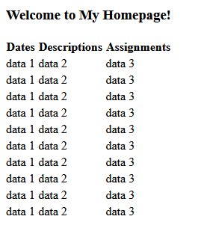

3. Use Windows Snipping Tools, take screen shot of the table in the web browser in the local drive, not uploaded to the server, copy/paste below:

## Part I - Task C - Polishing your table

To give your table a more polished look, you can include commands that will adjust the size of your table, add space in the cell, add space between rows, and align the data in a cell. Working with these commands is basically a process of trial and error to create the most appealing presentation of your information. The type of table that you create and the overall design of your web site will help you determine what works best for your table.

Some of the commands that enable you to customize your table include:

* The WIDTH=n% command sets the width of your table as a percentage of the screen.  The letter n designates the percentage that you assign to this command.  For example, if you want the width of your table to be one half the width of the screen, you would include the WIDTH="50%" command in the beginning table command.
* The CELLPADDING=n command adjusts the vertical dimension of the cells.  The letter n designates the numerical value that you assign to this command.
* The CELLSPACING=n command sets the space or border around the cells.  The letter n designates the numerical value that you assign to this command.
* The ALIGN=(LEFT, RIGHT, or CENTER) command will horizontally align the data in a cell.  For example, if you wish to place the data in the center of each cell in a row, you would include the ALIGN=CENTER command within the row command.
* The VALIGN=(TOP, MIDDLE, or BOTTOM) command will vertically align the data in a cell.  For example, if you wish to place the data in the center of each cell in a row, you would include the ALIGN=MIDDLE command within the row command.

In addition to the codes that were explained in the previous sections, the table below now includes some of these commands.

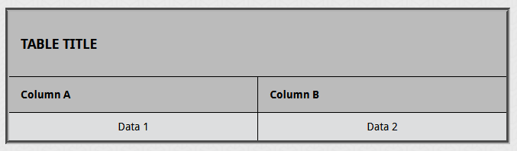

The following codes, along with codes previously discussed, created this table:

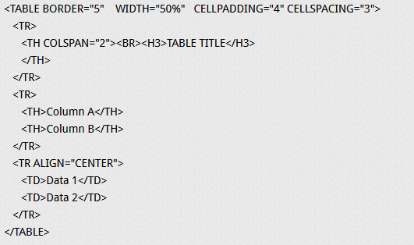

Notice that the TABLE command now includes the WIDTH="50%" command. This command extends the table across one half of the width of the text. Also, the CELLPADDING="4" command increases the vertical dimension of the cells, and the CELLSPACING="3" command increases the border around the cells. Finally, the ALIGN="CENTER" command places Data 1 and Data 2 in the center of the cell.

1. Continue with Task B, this time, you will need to create a table with the following attributes and properties.

border of 1 pixel, width of 80%, cellpade of 4 pixels, cellspacing is 3 pixels, and alignment is center.

2. Code the following table:

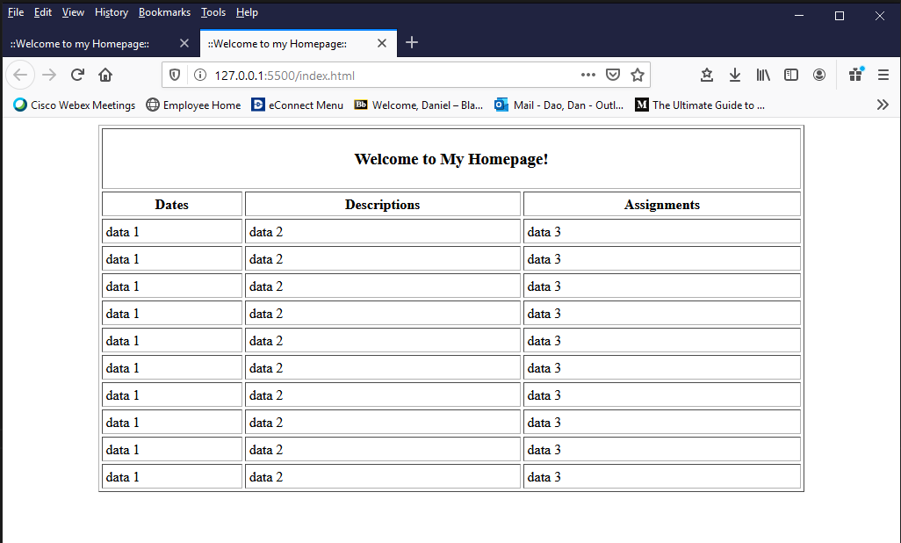

**3. Creating links**After you create your table, you can also create a link to another web page in one or more cells.  To do this, you need only include the link commands between the <TD> and </TD> commands.

Before you move on, please replace all “data 1”, “data 2” and “data 3” place holder text with &nbsp;

**&nbsp;** is a non-breaking space, a non-breaking space is a space that will not break into a new line.

Two words separated by a non-breaking space will stick together (not break into a new line). This is handy when breaking the words might be disruptive.

Examples:

§ 10

10 km/h

10 PM

Another common use of the non-breaking space is to prevent browsers from truncating spaces in HTML pages. If you write 10 spaces in your text, the browser will remove 9 of them. To add real spaces to your text, you can use the **&nbsp;** character entity. The non-breaking hyphen (&#8209;) lets you use a hyphen character (‑) that won't break.

After you replace all the data 1, data 2 and data 3, your index table should look like this:

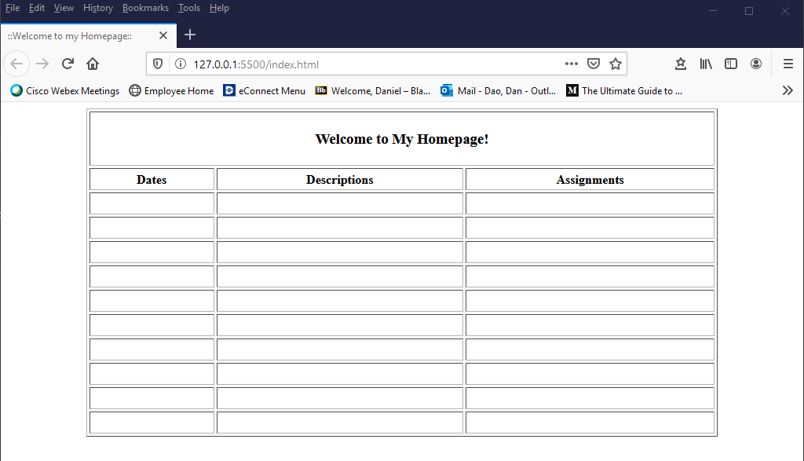

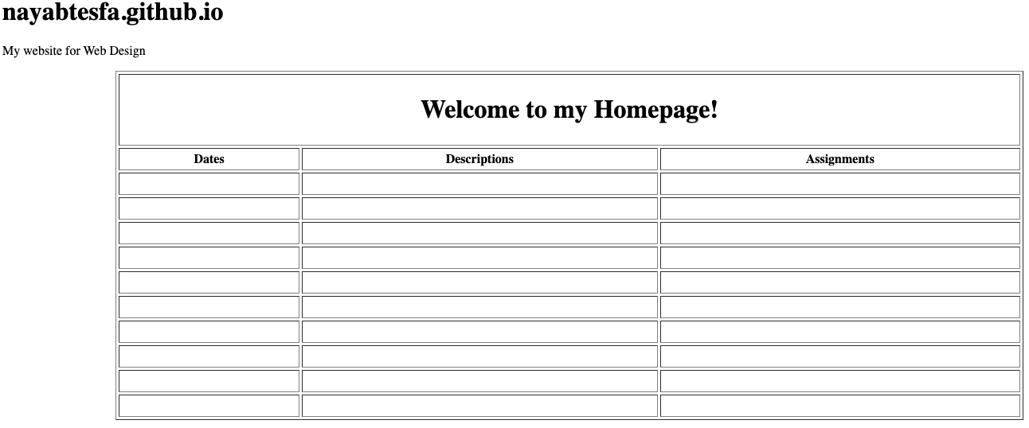

HTML <a> href Attribute - the href attribute specifies the link's destination. The link can be external webpage, internal webpage and link within a webpage.

Here's the syntax: <a href="URL">

**Attribute Values**  
Value Description

URL The URL of the link.

Possible values:

* An absolute URL - points to another web site (like href="http://www.example.com/default.htm")
* A relative URL - points to a file within a web site (like href="default.htm")
* Link to an element with a specified id within the page (like href="#section2")
* Other protocols (like https://, ftp://, mailto:, file:, etc..)
* A script (like href="javascript:alert('Hello');")

Please watch this video: <https://www.youtube.com/watch?v=78FHOoeSAA0>

==========================================================================================

**Part 1 – Task A, B, and C – ends here**

**Part 2 – Task A, B and C – starts here**

==========================================================================================

**Part 2 – Task A**

1. Write HTML Using MS Visual Code

Like in previous Class Exercise #1, web pages can be created and modified by using professional HTML editors. MS Visual Studio is industry Integrated Development Environment (IDE), which free, most industry IDE are free.

Please watch this video:

<https://www.youtube.com/watch?v=DLvBqZDaJaw>

A. HTML Headings

HTML headings are defined with the <h1> to <h6> tags.

<h1> defines the most important heading. <h6> defines the least important heading:

B. Between the <body> tags, this code:

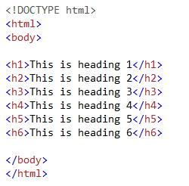

C. Using the Snipping Tool (Grab for Mac users) – please watch video in #3 before you copy/paste the image below:

NOT: You will need to repeat the above Steps 3 A, B and C for the following HTML code for Task B:

**Task B:**

1. HTML Paragraphs

HTML paragraphs are defined with the <p> tag, underneath the heading tags, insert the following code:

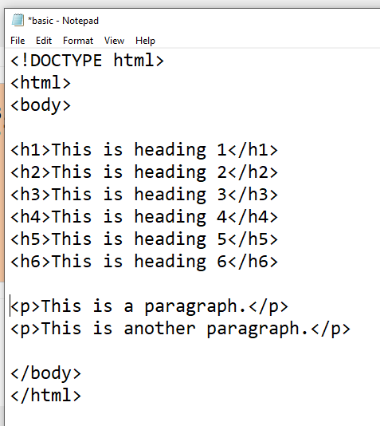

NOTE: I used Notepad text editor to demonstrate the code, this HTML code should in MS Visual Code editor, not Notepad text editor.

2. File > Save the basic.html page

3. Refresh your basic.html file in the web browser, like Task A – Step 3 above, take screen shot, copy and paste below of the web browser.

4. HTML Links – more information about like in couple of weeks.

HTML links are defined with the <a> tag:

Underneath the paragraph tags, insert the following code:

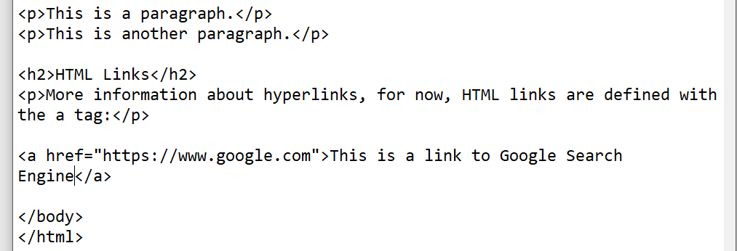

5. File > Save the basic.html page

6. Refresh your basic.html file in the web browser, like Task A – Step 3 above, take screen shot, copy and paste below of the web browser.

7. HTML Images

HTML images are defined with the <img> tag.

The source file (src), alternative text (alt), width, and height are provided as attributes:

Please watch this video:

<https://www.youtube.com/watch?v=T3S3-d78ln0&feature=youtu.be>

**NOTE:** Graphic formats for web browsers are: .jpeg, .jpg, .gif, .png, and .svg.

8. File > Save the basic.html page

9. Refresh your basic.html file in the web browser, like Task A – Step 3 above, take screen shot, make sure you include the entire graphic, copy and paste below of the web browser.

10. HTML Lists

Continue with the basic.html webpage with MS Visual Code editor.

HTML lists are defined with the <ul> (unordered/bullet list) or the <ol> (ordered/numbered list) tag, followed by <li> tags (list items):

Below your image tag, please insert the following code:

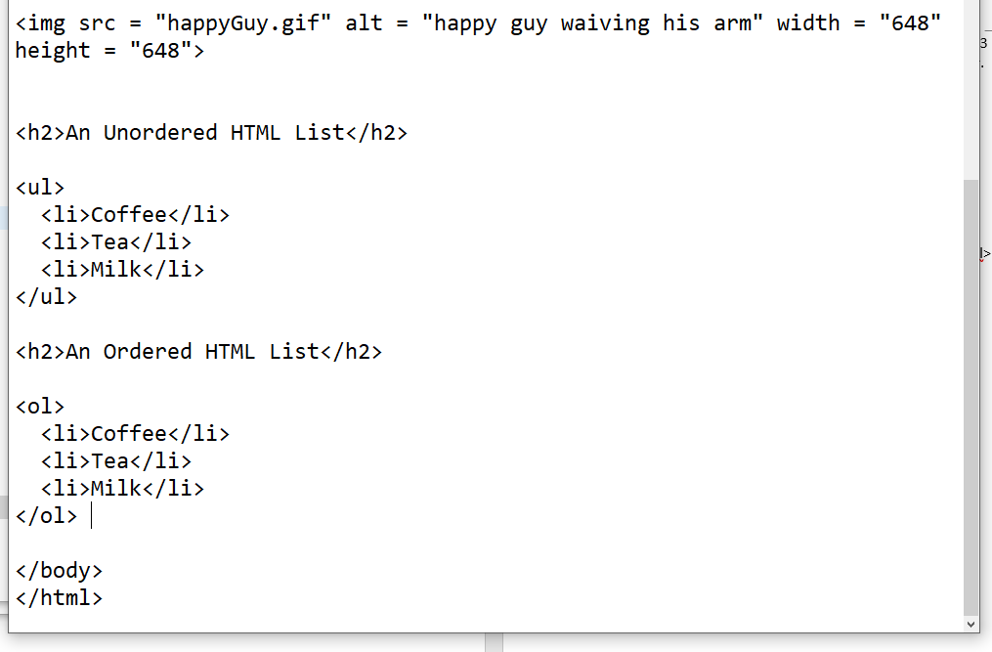

11. File > Save the basic.html page

12. Refresh your basic.html file in the web browser, like Task A – Step 3 above, take screen shot, make sure you include the entire graphic, copy and paste below of the web browser.

**PLEASE READ:**

**All of the above task are done in Notepad, you can do the same with MS Visual Code IDE as well. Please refer to eCampus > Lecture and Labs Information > Class Exercise #1 - Task #C – FTP Connection. Please read and watch all seven steps modules in this section. For the rest of the course, we will use MS Visual Code IDE, not Notepad to create and edit our HTML files.**

MS Visual Code IDE is an industry standard, bare minimum IDE, you will need to know before you enter the web or programming industry.

**Task C: Finishing Touch**

Please watch this video: <https://www.youtube.com/watch?v=L3hGVQziEGU>

**Everyone should receive the FileZilla FTP Account Information email, I provided you the URL address to your index page.   
  
Please paste your URL web address below:** [**https://www.mmlab2.rlc.dcccd.edu/imed1416-81102/web8220/**](https://www.mmlab2.rlc.dcccd.edu/imed1416-81102/web8220/)

**Make sure this URL web address loads your index.html page, that’s how I will grade all assignments.**

**For example, this URL web address:** [http://www.mmlab2.rlc.dcccd.edu/imed1416-8XXXX /web85YY](http://www.mmlab2.rlc.dcccd.edu/imed1416-8XXXX%20/web85YY)

**XXXX in this URL address is the section number and will change every semester. Please check and will vary section numbers for every semester. Please use the URL address link that I sent you.**

**YY in this URL address is your user name and web directory, and will vary. Please check your username.**

**Make sure you put the correct URL address, not your local computer address. To grade, I need the URL address that’s on the web server that you used the Filezilla FTP your files. The following local computer address is not what you want to send me, because I cannot access this file from your computer.**

**file:///C:/Users/dxd8401/Documents/IMED1316/index.html**

**This address is on my local computer not the web server, can you see the difference? Please say yes. You cannot access my local drive, or I cannot access your local drive to grade, please know this difference between the two addresses (URL and local computer addresses).**

**Please link from your index.html to basic.html page and link from basic.html back to index.html. All future assignments will be similar format and process. The index.html will serve as the main page for your web directory, and all files will link from this index.html page.**

**File Management 101 – please “mirror” your local drive and the web server file directories, these two file structure must be mirror of one another (replica). If you cannot link it from one html file to another, then you cannot link it on the web server. Please make sure everything is working properly on your local computer before you upload to web server.**

**When do I grade your index.html page?**

**All assignment are due on due date of the assignment, check the course calendar, and I grade the index.html page on the same day. Please complete and update your assignment appropriately.**

**For the rest of the course, in regards to all Class Exercises, you will submit the Class Exercise document with the screenshots of your .html webpage, not the html code, in eCampus. I provided the code and don’t need screen shots of the code, please take screen shots of the web browser for the appropriate sections (highlight yellow). Please use Snipping Tool and make sure it’s readable.**

**If you can’t read the Snipping Tool screen shot, then I can’t read it.**

**Please let me reiterate and clarify what to submit?**

1. **Everyone will need to complete this document with all the screen shots in the appropriate area (yellow highlighted), keeping it .docx format, do not change .docx format; you will upload this document via eCampus before due date.**
2. **Make sure your index.html is properly loaded and copy/paste your URL web address to the proper section above.**

**Dan**